

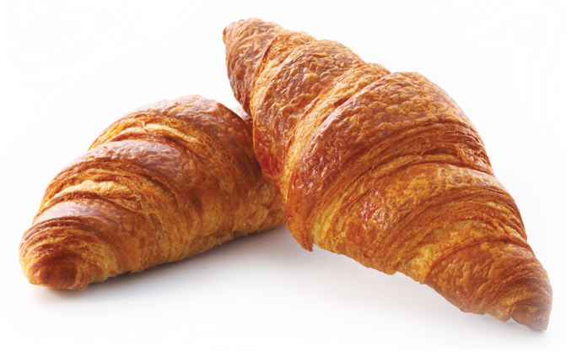***Children’s Party Menu Feb 2025***

Prices exclude VAT

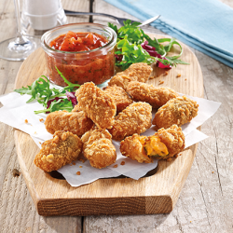 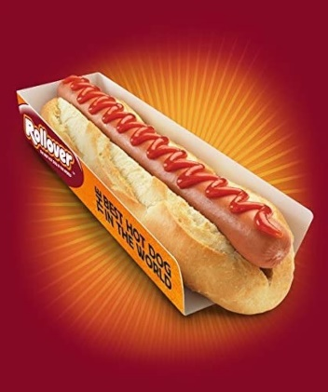 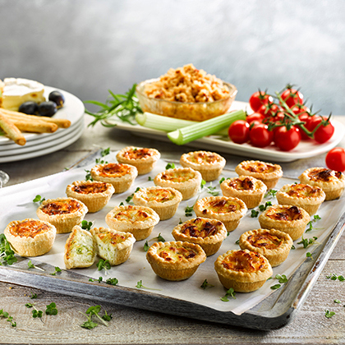

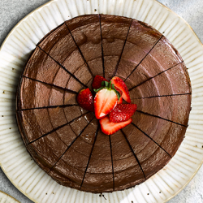 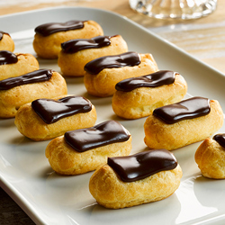

***Mini Treats Package*£12.50pp**

Includes six savory items, crisps, soft drink and two sweet items. Minimum Order = 10 guests. Individual savory items, crisps and drinks can be purchased separately @£1.70+vat per item. Sweet items @£1+vat per item.

**Mini Quiche Selection** (2pp)

4 Varieties: Cheddar Tomato & Basil (V), Stilton & Broccoli (V), Cheddar & Chive (V), Bacon & Cheddar

**Corn Dog on a stick** (1pp)  Mini Hot Dog in a crusty tasty batter served with Ketchup & Mustard

**Mac n Cheese Bites** (2pp) (V)

With a Tangy Salsa sauce

**Crispy Chicken Goujon** (1pp)

Served with a Garlic Mayo Dip

**Popcorn Chicken** (2pp)

Served with a Sweet Chilli Dip

**Cheese & Tomato Mini Pizza** (2pp) (V)

**Ready Salted Crisps** (1x30g bag pp) (V)

**Mini Caramel Doughnuts** (1pp) (V)

**Mini Chocolate Eclairs** (2pp) (V)

**Radnor Splash Juice Drink** (1pp) 25oml Orange & Passionfruit or Watermelon juice carton

 ***Party Package* £12.50pp** Includes a Hot Dog/ Burger, Chicken Nuggets/ Jalapeno Poppers, Potato Wedges & a can of Pep Max 330ml. Minimum Order = 10 guests. Individual Rollover items@£4+vat each, Wedges @£2+vat, Pep Max, Tango Orange, Pepsi Max Cherry cans 330ml = £1.50+vat

**The Original Bockwurst Hot Dog /**

Smoked Beechwood Bockwurst sausage in a Baguette

**Veggie Vegan Hot Dog (Ve)** **/**

Great tasting vegan hot dog

**Chicken Hot Dog /**

Pure Halal Chicken Beechwood sausage

**Rollover Cheeseburger**

Flame grilled beef burger with cheese

**Rollover Chicken Nuggets** (6) **/**

**Rollover Jalapeno Cheese Poppers** (4) (V)

**Skin on Potato Wedges** (200g serving) (Ve)

**Pepsi Max/ Tango Orange** (330ml can)

***Additional items: Drinks***

Prices exclude VAT

**Mineral Water (750ml)** **£2.50**

Still/Sparkling Glass bottle

**Mineral Water (500ml)** **£1.50**

Still/Sparkling Carton

**Canned Soft Drink (330ml)** **£1.50**

Coca Cola, Fanta, Diet Coke, Sprite

**Bottled Soft Drink (500ml)** **£2.20**

Coca Cola, Fanta, Diet Coke, Sprite, Lilt

Innocent Super Smoothie 300ml **£3.00**

**Carafe of chilled water (1L)** **£1.60**

Serves 4-5

**Carafe of Squash (1L)** **£2.60**

Blackcurrant & Apple / Orange Serves 4-5

**Carafe of Juice (1L)** **£4.00**

Orange, Apple. Serves 4-5

***Sweet treats***

**Premium traybake squares** (1pp) **£1.30**

Caramel Shortcake (V), Chocolate Orange Tiffin(V), Vegan Fruity Flapjack (Ve)

**Fresh Fruit Mini Skewer** (1pp) (Ve)  **£1.30** (melon, pineapple & strawberry / Seasonal Fruit

**The Handmade Cupcake Selection** (1pp) (V) **£3.00**

Sicilian Lemon, Carrot & Mascarpone, Red Velvet, Belgian Chocolate

**Indulgent Cake Slice** (1pp) **£3.80**

Chocolate Cake (V)

Lemon & Blueberry Cake (Ve)

Gluten Free Cappuccino Cake (GF)

(chose any one)

**Celebration Cake £20.00**

Two Layer Chocolate Gateaux (V, whole, uncut, around 14-16 slices)

***Lunches for Adults***

**Sandwich, Tortilla Wrap, Baguette, Sushi Platters**

**Premium Meat £30.00**

Roast Chicken Salad, Ham Hock & Smoked Cheddar, Chicken & Chorizo and Bacon Lettuce Tomato (BLT) Sandwich Selection.

Serves 6 (24 Quarters per platter)

**Premium Vegetarian £30.00** Cheddar Ploughman's, Egg & Cress, Cheese & Onion and Veggie New Yorker Sandwich Selection. Serves 6 (24 Quarters per platter)

**Premium Fish £30.00**

Prawn Mayonnaise, Prawn Cocktail, Tuna Mayonnaise, and Tuna & Sweetcorn Sandwich Selection. Serves 6 (24 Quarters per platter)

**Premium Halal £30.00**

Halal Sourced Chicken Mayonnaise, Chicken & Sweetcorn, Roast Chicken Salad and Piri Piri Chicken Sandwich Selection. Serves 6 (24 Quarters)

**Premium Vegan £30.00**

Coronation Chickpea, Spiced Three Greens Medley and Vegan Ploughman's Sandwich Selection. Serves 6 (24 Quarters per platter)

**Tortilla Wrap Bites – Mixed £30.00**

Chicken Tikka, Hoisin Duck and Tuna & Sweetcorn Wrap Selection. Serves 3-5 (16 pieces per platter)

**Tortilla Wrap Bites – Vegetarian £30.00**

Spicy Mexican Style Cheese & Beans, Falafel & Yoghurt and Moroccan Medley Wrap Selection. Serves 3-5 (16 pieces per platter)

**Tortilla Wrap Bites – Vegan £30.00**

|  |
| --- |
| Sweet and Spicy Chickpea, Moroccan Rainbow & Bang Bang Chickpea.. |

Wrap Selection. Serves 3-5 (16 pieces per platter)

**Mixed Baguette Platter £30.00**

|  |
| --- |
| Ploughman’s & Chicken and Bacon Caesar |

Baguette Selection. Serves 3-5 (16 pieces per platter)

**Fish Sushi Sharing Platter** **£40.00**

Prawn, salmon & smoked salmon nigiris with salmon & avocado and chicken katsu rolls. Includes wasabi, soy sauce, ginger, sweet chilli mayo and crunchy fried onion

Serves approximately 8 (28 pieces per platter)

**Vege Sushi Sharing Platter (V) £40.00**

Egg and fried tofu nigiris with spicy tofu and vege California rolls. Includes wasabi, soy sauce, ginger, sweet chilli soy and crunchy fried onions

Serves approximately 7 (24 pieces per platter)

**Vegan Sushi Sharing Platter (Ve) £40.00**

Carrot & burdock and spicy tofu rolls with pumpkin and roasted red pepper nigiris. Includes soy sauce, wasabi and ginger

Serves approximately 7 (25 pieces per platter)

**Gyoza Platter (Ve) £28.00**

With a Sweet Chilli Soy

Serves approximately 7 (25 pieces per platter)

**Chicken Katsu Platter £28.00**

With a Sweet Chilli Mayo Dip

Serves approximately 7 (25 pieces per platter)

**Vegetable Crudities Platter (Ve) £28.00**

A classic selection of chopped vegetables to include carrot, cucumber, peppers, Radish and cherry tomatoes and a roasted pepper hummus Serves 10

***Crisps& Nibbles***

**Bowl of Premium Hand cooked £10.00**

**Sea Salted Crisps**

Bowl of 300g. Serves approximately 10 (Vegan, Gluten free)

**Bowl of Eat Real Lentil Chips £12.00**

Bowl of 270g. Serves approximately 6-8 (Vegan, Gluten free)

**Sweet Chilli / Original Salted Pretzel Thins £5.50**

Per bowl (105g). Serves approximately 4-6

Prices exclude VAT

***V -denotes Vegetarian, Ve – Plant Based, GF- Gluten Free***